Voice Acting Information for :
Kira Buckland
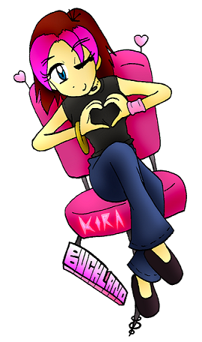
E-mail : kira@kirabuckland.com
Website: http://www.kirabuckland.com (includes demo reels)
Location : Los Angeles
Bio: Kira started voice acting in 2004 by doing online projects such as flash animations and games. She first got noticed professionally in 2007 upon winning the AX Voice Actor Idol competition. Since then, she has appeared in various video games such as Castle Crashers, Skullgirls, Dynasty Warriors (6 Empires + NEXT), Luminous Arc 2, and a lead role in an upcoming undisclosed RPG. She also runs a forum called the “Voice Acting Club” which links producers with online voice talent.

